Kishan Patel

August 06, 2020

Where to Build a Hotel?

Hotels play an intricate role in the lives of everyone. Whether you are going on vacation or a business trip, a nice hotel is almost always on every person's itinerary. For any individual looking to build a hotel, one of the most important questions to answer is where to build the hotel. The location of the hotel plays a major role on whether to the hotel will survive or not. The hotel can have the best staff and service in the world, but if the location is not right, the hotel will end up failing. Therefore, a variety of factors can be used to determine the best location to build a hotel. In this case, the question that will be answered is: Where should one build a hotel in Sugar Land/Houston, Texas area?

Factors that play a role in determining where to build a hotel include proximity to restaurants, parks, museums, and convention centers. The reason these four factors where used because they each apply to one or more of the following activities: family vacations, business trips, and casual hangout spots This project aims to use data associated with the four factors to determine where to build a hotel.

To start off, data was gathered from Foursquare regarding the thirty closest restaurants, parks, museums (there were only four museums in the radius limit), and convention centers to the city of Sugar Land in a 10000-meter radius. The data received consisted of latitude and longitude points for each venue. The goal was to find the average longitude and latitude values to determine the best place to build a hotel. The reason this approach was taken was because it would output a location that was near all venues found in the dataset. Once the average latitude and longitude values were found, they were plotted on a map

After performing the analysis, it was found that the location of the hotel should be 29.6260414773169 latitude and -95.62335572777322 longitude.

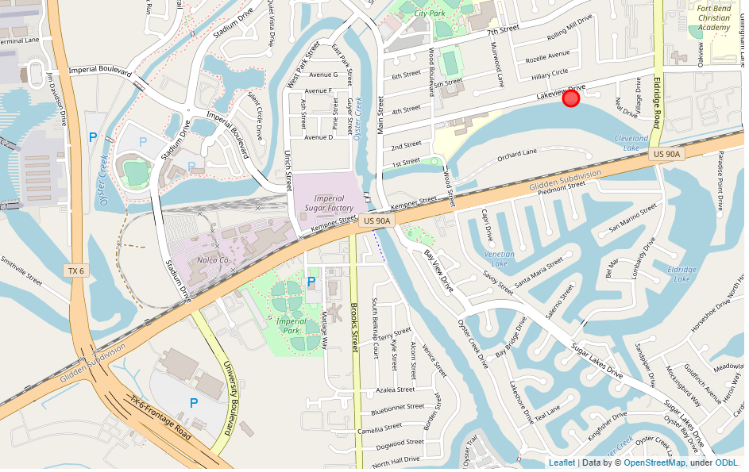

One observation that was made was the location is close to a railroad. Thus, if a hotel is built, there needs to be high quality noise proof walls in the structure. It is recommended the hotel is built on Eldridge Road, which is a little east of the actual location found, so it does not interfere with the residential area and it can be seen from Highway 90.

In conclusion, after analyzing the data of various venue locations in the Sugar Land/Houston area, it was determined Eldridge Road was the best place to build the hotel. The accuracy of this analysis can be even further increased if more factors are considered. In the end, a strong recommendation is made to build a hotel at this location.